

Buckinghamshire Council

New Starter Induction Manu

[Insert Name]
2023/2024

Contents
A Warm Welcome to the Buckinghamshire Educational Psychology Team! 3
Who is in your team? 4
Where is the office and where do we work? 4
Where do I park and how do I apply for my permit? 5
Parking charges 6
Team meetings 6
Induction Timetable 7
General Information 9
Working Hours 9
Annual Leave 9
Sick Days 9
Email Setup 10
Calendar 11
Coaching for Performance (not applicable to TEPs) 11
Expenses - (not applicable to TEPs) 11
Useful Contact Numbers 12
ID cards 12
Sharepoint 13
How to request annual leave 14
How to claim expenses 15
Raising an issue with IT 18
Tasks to get settled in 19
Bucks Induction Training 20
Office Top Tips 22
Amersham Office 22
High Wycombe Office 23
Statutory casework 24
Report templates 24
Who do I send my report to once it is complete? 24

A Warm Welcome to the Buckinghamshire Educational Psychology Team!

Dear ----,

It gives us immense pleasure to welcome you to the Buckinghamshire iSEND Service, specifically the Chesham and South Bucks Hub. We believe you are joining an ensemble of dedicated professionals who work diligently to make a difference.
As you peruse your induction manual, we trust you will find it insightful, offering a comprehensive backdrop about our service and the nuances of your role. While the manual is designed to be thorough, never hesitate to approach any of us if you have queries or require additional information.
Our wish for you is a smooth and fulfilling integration into our community. We're excited for the energy and dedication you'll bring, and we're looking forward to the collaborative ventures ahead.
Once again, welcome to the fold! We're confident you'll find your experience here enriching and rewarding.

Warm regards,
The Buckinghamshire Educational Psychology Team
Chesham and South Bucks Hub

Who is in your team?
Name | Role | Mobile number
Dr Scott Ighavongbe-Patrick | Senior Educational Psychologist | 07812 788671
Bozena Barnet | Educational Psychologist | ?
Victoria Ingram | Educational Psychologist | ?
Dr Siobhan Hickey | Educational Psychologist | ?
Dr Enrique Childress | Educational Psychologist | ?
Dr Yasmin Lazarus | Educational Psychologist | ?
? | Trainee Educational Psychologist | ?
Rajpreet Kataria | Assistant Educational Psychologist | ?

Where is the office and where do we work?
The CSB office is now located at King George V House, King George V Road, Amersham, HP6 5AW, however this is closing soon. The office operates from 9am to 5pm. Should you need to access it earlier, the back entrance is available for use with your ID card. The iSEND working area is conveniently situated on the Ground Floor, adjacent to the reception. Assessments are stored in the cupboard within the EP area. Please remember that access to the ISEND area requires your badge. Please note, there have been discussions about relocating the office. We'll ensure you're updated with any further developments regarding this matter.

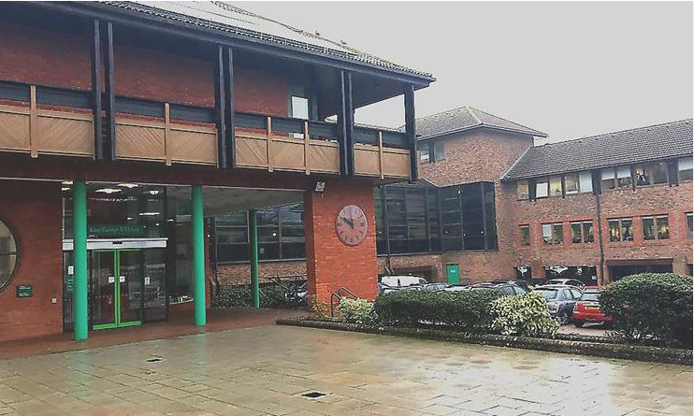

Where do I park and how do I apply for my permit?
Parking is available at the Amersham Multistorey Car Park, which is a only a few minute’s walk from the office. The allocated parking for Aylesbury and High Wycombe is listed below:
Aylesbury | Walton Street Car Park, Walton Street, Aylesbury HP21 7QP.
High Wycombe | Easton Street Car Park, Easton St, High Wycombe HP11 1NT

To apply for your parking permit:
- Visit the MiPermit website: secure.mipermit.com/bucksstaff/application/home.aspx
- Click on ‘Obtain Digital Permits’ (on the left hand side of the page) or the ‘Staff Parking Permits’ box (under the Digital Permits section on the page)
- Complete the form on the Obtain Staff Permit page
  - Add your car registration number – you can only add one registration number for your staff permit
  - Choose a start date
  - Enter your name and work email address
  - Select your directorate – if you are unsure, please check on the organisation chart before submitting your form
- Click ‘Finish’
- You will be then be given the option to create an account. Please use the same email address used on the form. By setting up an account, you will be able to amend your permit details if required.
- Your request will be sent for approval. Once your request has been reviewed, you will receive an email

Please note:
- it may take a few days for your permit to be reviewed and you will not be able to receive free parking until confirmation has been received
- Your registration details will be added to a list letting enforcement officers at the car parks know you are entitled to free parking
- If you are not on the list, a penalty charge notice (legislation) will be issued. If a notice is issued, the statutory process will apply - notices will not be cancelled.
- Once approved, your permit will be valid for 12 months

Please remember that these MiPermit arrangements only apply to car parking during working hours and only in the car parks listed above. If you are parking outside working hours you must pay as normal. Any misuse of this MiPermit scheme would be considered to be a misconduct issue.
Until your parking permit is authorised, you can pay for your parking and claim this back through expenses, which is explained below.
NOTE: For any parking enquiries, please email parking.services@buckinghamshire.gov.uk

Parking charges
Amersham Multi-Story Car Park (RingGo- 9020)
1 hour | 2 hours | 3 hours | 4 hours | 10.5 hours
£0.80 | £1.50 | £2.10 | £2.60 | £6.10

Team meetings
CSB team meetings are held on the third Wednesday of every month, typically from 1pm-2pm. These are intended to be held face to face where possible, however can be accessed via Teams if needed. As a team, we aim to work from the office at least once a week on a Wednesday, where possible.

Induction Timetable

September
2023
Monday | Tuesday | Wednesday | Thursday | Friday
 |  |  |  | 1
4 | 5 | 6 | 7 | 8
11 | 12 | 13 | 14 | 15
18 | 19 | 20 | 21 | 22
25 | 26 | 27 | 28 | 29

October
2023
Monday | Tuesday | Wednesday | Thursday | Friday
 |  |  |  | 2
5 | 6 | 7 | 8 | 9
12 | 13 | 14 | 15 | 16
19 | 20 | 21 | 22 | 23
26 | 27 | 28 | 29 | 30

General Information

Working Hours
These are generally:
- 9am – 5pm if you take a 30 minute lunch break.
- 9am – 5.30pm if you take an hour lunch break.

Buckinghamshire Council operates a flexible working scheme where core hours are 10am until 3pm. You must be available for work between these hours. Outside of these hours, your workday can be more flexible, i.e. if you wanted to start at 8.30am and leave at 4.30pm etc. then run it by your line manager. We work 7.4 hours per day (equates to 7 hours and 24 minutes) which means that you can leave at 4.30pm on Fridays (yay!)

The flexi-time system which allows you to take time off if you work over your contracted hours. You can work up to a day overtime and claim this back as time off in lieu one day per month with agreement from your line manager. You can also make up time in this way, where you can take some time off and work it back (e.g. if you needed to leave at 4pm one day you could stay 30 minutes later or start 30 minutes earlier on two days.)

Talk to your line manager to agree any flexi-time working. It may also be a good idea to keep an Excel timesheet if you are working flexi hours up/back.

Annual Leave
Your contract will set out how many days Annual Leave you are entitled to and SAP will reflect this in hours. Annual leave is booked through SAP (step by step instructions below) but it’s always a good idea to discuss this with your line manager to let them know that you’re thinking of taking leave. We must put this in our Outlook Calendar for everyone to see so people know where we are.

SAP automatically records how many days you have left of Annual Leave but it may be a good idea to keep your own record. With agreement from your line manager, you are allowed to carry over a maximum of 5 days pro rata into the next leave year.

Sick Days
Call or email the office and Business Support. They will email your manager/supervisor for you or you can email them yourself.
You will be required to complete a return to work form when you have recovered.
Further details can be found on the Intranet.

Email Setup
You will need to set up an email signature and out of office message as well as an answer phone message. Please find templates of each below which can be modified for your role and location.

Your email signature should copy the following:
Joe Bloggs
<Add Role>
Integrated SEND Service – CSB
Buckinghamshire Council

<Add Work Number>
Joe.Bloggs@buckinghamshire.gov.uk

King George V House, King George V Road, Amersham, HP6 5AW

Your out of office message should consist of the following:
Thank you for your email to the Integrated SEND Service, I am out of the office until <add date>.

Please note that this inbox will not be monitored in my absence.

If your matter is urgent please email Educational Psychology Business Support on epsadmin@buckinghamshire.gov.uk.

Alternatively please call Educational Psychology Business Support on 01494 732 187 and the team will assist you.

Otherwise I will respond to your email on my return.

Kind Regards,
Joe Bloggs
<Add Role>
Integrated SEND Service – CSB
Buckinghamshire Council

King George V House, King George V Road, Amersham, HP6 5AW

Your day to day work mobile answer machine message should copy the following:
You have reached the answer machine message of <add name>, <add role> ,CSB. I am currently away from my desk and am unable to take this call.
If this matter is urgent please call 01494 732 187 and they will assist you.
Alternatively please leave a message and I will return your call as soon as possible.

Your work mobile answer machine message whilst you are away on Annual Leave should copy the following:
You have reached the answer machine message of <add name>, <add role> ,<add hub> I am currently on annual leave and will return on <add date>.
If this matter is urgent please call <add appropriate main business support landline number> and they will assist you.
Alternatively please leave a message and I will return your call as soon as possible.

Calendar
Keep your Outlook Calendar up to date and include annual leave, sick days, visits and remote working so people know when you’re available.

For Assistant EPs we recommend you continuously look at EP Outlook calendars and send round emails asking whether you can accompany them on any visits (or virtual meetings) they have. Shadow a range of EPs to see their different styles and approaches. Ask them what assessments they are using so you can try to see a range being done throughout the year. Don’t be afraid to ask!

Coaching for Performance (not applicable to TEPs)
This is a new system for us but essentially it is a process for managers and staff to review performance and for managers to help employees deliver the right outcomes and perform to their best. It consists of a mixture of informal chats and formal meetings in which you will jointly agree short term work goals for the next three months. This will be explained in more detail during your regular supervision and line management meetings but further information can also be found on ‘The Source’ which can be useful to look at before your meetings.

Expenses - (not applicable to TEPs)
You can claim for expenses you incur in your job role through SAP. You can log a month’s expenses in one go or do it as you go along. Just make sure that you have submitted them by the 12th of each month for it to be included in your monthly payslip. From experience we would suggest keeping a record your expenses so you can ensure you have been reimbursed.

As you will use your car for your work, you will need to ensure you are covered for business use on your car insurance. You are classed as a critical car user and as a result you are able to claim business mileage and parking costs back. You will also receive a crucial car user allowance which works out as £25 a month. If you don’t receive this on your first payslip you will need to tell your line manager and they will look into this further for you. The expense system is quite easy to work out once you have done it a few times but ask if you would like help to complete a claim.

To calculate your mileage:
Add up all the miles travelled and deduct the amount you do to commute to and from your normal base.
- For example, if your daily commute (to and from work) is 15 miles but you do a total of 45 miles in one day, you can claim for 30 miles that day.

Parking is free at Abbey Centre but at Amersham and Wycombe offices you will have to park in nearby car parks and claim back your costs through expenses. Car parks and associated costs of each area have been added under the ‘Office Top Tips’ section.

We would highly recommend downloading the ‘Ringgo’ app which can save you when you’ve run out of spare change. Numerous members of the team use this app for all parking sessions now (it’s a complete life saver!)

Useful Contact Numbers
Keep these safe - it can be useful to save these contacts in your phone as we can guarantee you will need to contact them more than once!

Amersham Office | 01494 732187
Abbey Centre | 01296 383030
Wycombe Office | 01494 475199
IT Helpdesk | 01296 383388
HR | 01296 382233

ID cards
Collect your ID card (with access to all offices enabled) from Security located behind reception at Walton Street. Take your DBS certificate with you.

It’s also important that you wear your ID card on school visits as they may need to photocopy it for their records.

Sharepoint
All of our files are stored on SharePoint and guidance on how to use this can be found
- SharePoint - FAQs & How To Guide
- SharePoint - web portal
- SharePoint - Collaboration and storage presentation
- Staff SharePoint training session-20220803_110221-Meeting Recording.mp4

Please feel free to ask us if you’re stuck on how to use it.

How to request annual leave
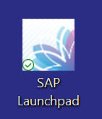
To request annual leave, you’ll need to use SAP Launchpad, which should be installed and the icon should be on your desktop. If this isn’t there, you will need to raise a ticket with IT (see the section below for how to do this).
Once in SAP, you will need to select ‘My Leave Requests’.
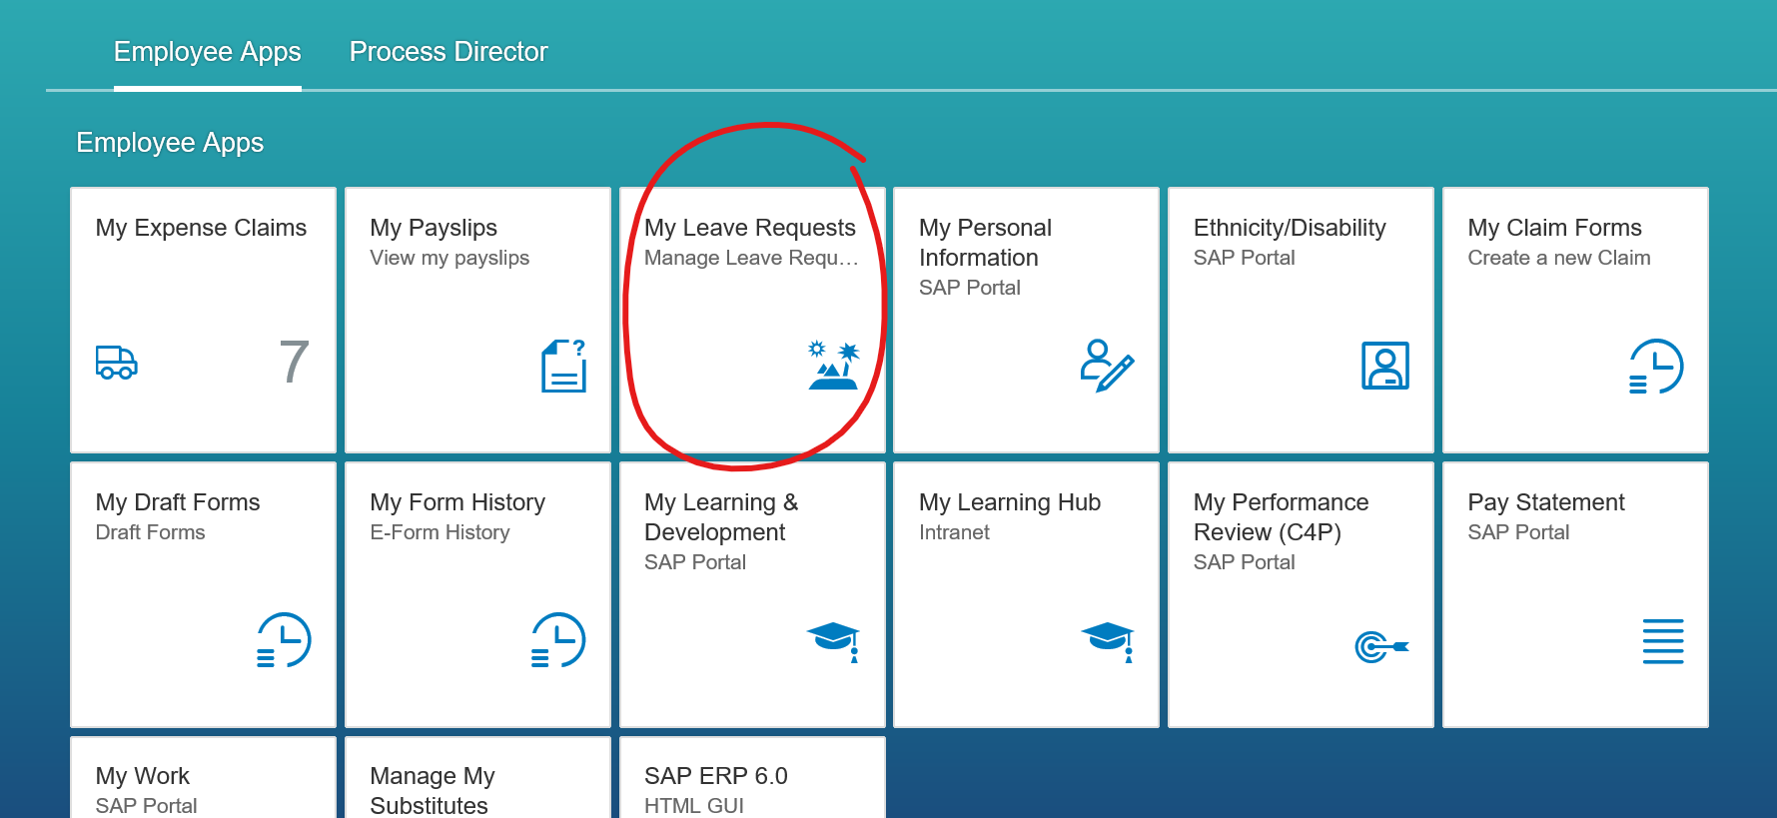

From there, simply select the dates you wish to take annual leave and click send. You will see the amount of leave you have used and how much you have left, in the top right hand corner of the screen. Once sent, this will be received by Keith and an email will be sent to you once it has been approved.

How to claim expenses
To claim expenses, you’ll need to go through SAP and select ‘My Expense Claims.’
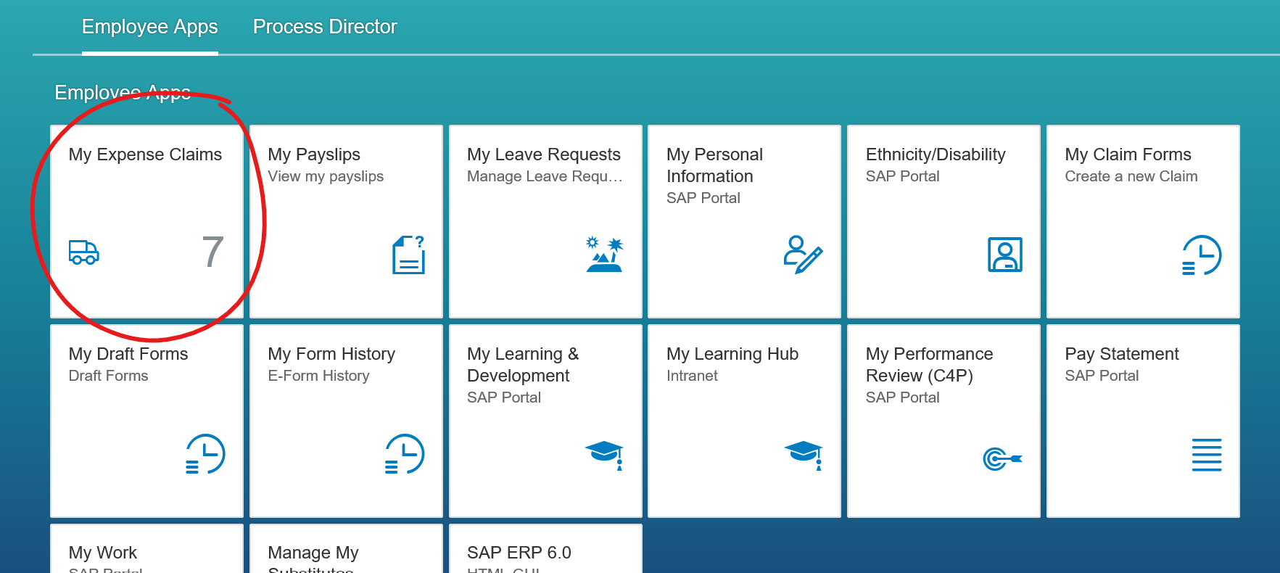

Next, click on the + button on the bottom left of the screen, and click ‘Create New Claim.’
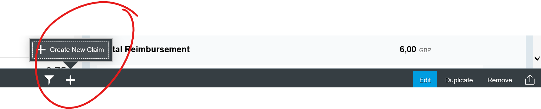
You will then be presented with a new screen
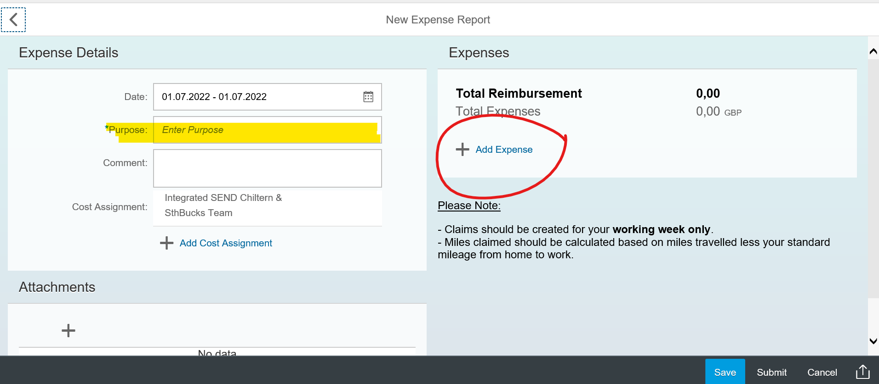

In purpose, you put what you are claiming for E.g. travel, parking, refreshments for a team meeting. Next click, ‘+ Add Expense.’

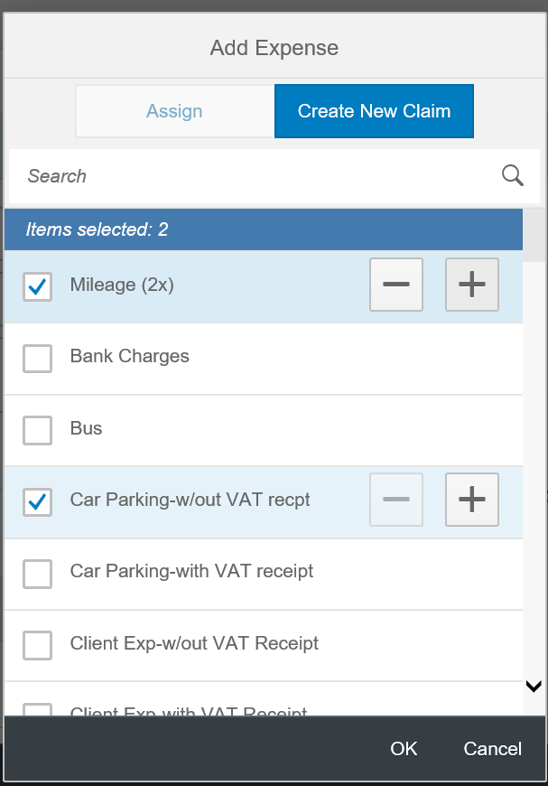

Select the claim, which is usually ‘Mileage’ or ‘Car Parking’ (you don’t need a VAT receipt for this). You can select the number of separate claims you wish to make by selecting the ‘+’ button next to each one. For example, if you parked visited 2 different schools, you would make 2 mileage claims.
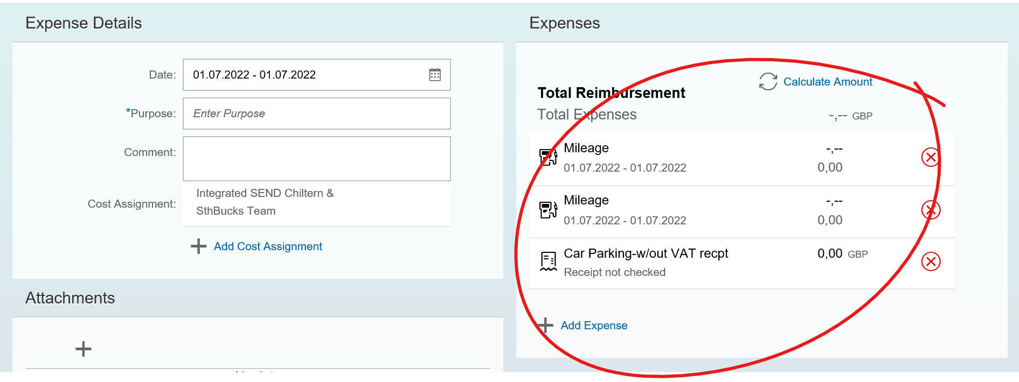
Select one of your claims. As mentioned previously, if claiming mileage, this is claimed from the distance from the office. When claiming for car parking, you will see that the amount is 0,00. Instead of a decimal point, use a comma to separate pounds and pence. E.g instead of 1.25, it would be 1,25.

Once done, select ‘Save and Back,’ on the bottom right hand side of the screen. You can add more expenses by clicking + Add Expense, or if you want to wait to add more for the rest of the week, you can save the expense. Once you have finished your claim, click submit and this will be sent to Keith to approve.

Raising an issue with IT
To raise an issue with IT, open your web browser and this should show The Source. Scroll down and you should see a section called ServiceNow (log a ticket). You’ll need to select Log an issue, which then takes you to a form that you complete. Once submitted, you’ll receive an email to confirm your issue has been logged, and IT will be in touch to let you know when this has been resolved.
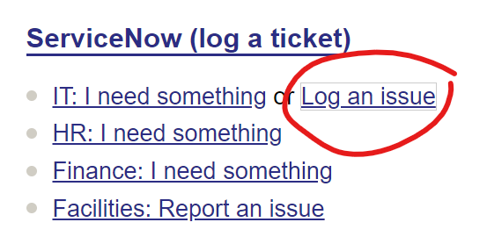

Tasks to get settled in

- Collect your new laptop and mobile phone. You will need to visit IT on floor 9 at Walton Street in Aylesbury to get your laptop and phone allocated. IT will provide set up instructions. Check the IT acceptable use policies: https://buckinghamshire.itpolicysystem.com/

- Whilst at Walton Street in Aylesbury, pick up your ID card if it is ready for collection. Bring your DBS certificate along with you. Collection times are 10-12pm and 2-4pm.

- Gain access to the SharePoint and email system.

- Access the Outlook Calendar and keep it up-to-date (and share/open it).

- Set up your email signature.
Select options under the ‘File’ tab then select ‘mail’ on the left hand pane and choose ‘signature’. Then create your new email signature, it should follow the examples provided in the ‘General Information’ section.

- Set up your out of office message.
Select ‘File’ and ‘Automatic Replies (Out of Office)’. Then write up your out of office message. Your message should follow the examples provided in the ‘General Information’ section.

- Set up your answer phone message for your work mobile. Remember that you will have one for day-to-day business and the second for annual leave.

- Ensure Whatsapp is set up on your phone. Ask an EP to invite you onto the team EPS Whatsapp group and your EP hub Whatsapp group

- You may need to gain access to the Nurture email inbox (Vic ‘owns’ this inbox).

- Put key dates (e.g. service days and team meetings) into your Outlook Calendar.

- Victoria (Vic) Ingram is our AEP representative – Victoria.ingram@buckinghamshire.gov.uk . Please let her know if you are a TEP or EP member so that you can be added to the mailing list and included in Trade Union communications.

- Get set up on the printer. At present we do not have permission to print confidential work documents at home.

Choose a time when you are working in the office and your laptop is connected to the network through a cable. Click the following link \\EQPrint-DRE-01\FollowYou and choose ‘Open’. It will take a couple of minutes for the new print queue to be set up on your laptop. Once you see this window the setup is complete and you can close the window straight away by clicking on the ‘X’ in the top right corner.
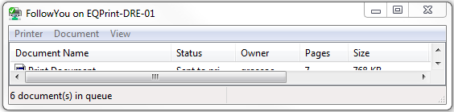

- Register your ID card on the new printer
Hold your card over the card reader on the printer and when requested type your username and password on the printer screen. Please type them exactly as you do when you log onto your computer.

- Ask someone to show you how to use BucksNet to book and cancel meeting rooms in all the bases and at Green Park. iSend Support Officer, Lee Horlock may be able to support with this.

- For Assistant EPs we would highly recommend joining the private Facebook group ‘Educational Psychology – Doctoral Applicants’. It has a wealth of resources, tips and advice really useful for the doctoral application.

- We also recommend Assistant EPs join ‘EPNet’. It is an online mail list specifically for the Educational Psychology community. Updates can be extremely frequent so we suggest selecting the digest option. If you have trouble subscribing, contact EPNet admin who will sort it out for you.

Bucks Induction Training
- Complete your online training. Your SAP profile provides a link to the e-learning portal. All members of staff need to complete mandatory e-learning 1(GDPR) and 2. Other essential training includes Welcome to Buckinghamshire Council, Safeguarding, Health and Safety, Prevent and Equality and Diversity. These can be found by following: https://buckinghamshirecouncil.learningpool.com/login/index.php If a password is needed for e-learning email the Service Desk.

At present, the Council is in the process of developing policies and guidance for the new unitary authority. If you cannot find something on The Source (under You and Work), you may need to refer back to Bucks County Council (BCC) policy and guidance for information: https://intranet.buckscc.gov.uk/how-do-i/human-resources/

Office Top Tips

Amersham Office
The doors for this building open at 9am and close at 5pm so if you arrive early or leave after 5pm you need to exit/enter the building through the car park underneath the office (a member of Business Support will show you the way).

Always use your own ID to get in/out of the building and for printing.
You can set up with your laptop anywhere on the ‘hot desks’ but the Educational Psychologists tend to sit on the desks closest to the kitchen. You can also connect your laptop to the bigger screens.
Each Hub has allocated Educational Psychology Business Support. Currently Sonia Legg supports both Amersham and Wycombe hubs. If you have an office-related query, please ask the iSEND Support Team.
If you haven’t already received a mobile phone you will get one from IT. This is for making work calls to colleagues and settings. Please look after it carefully as damages will be charged to your team.
Skype for Business will load on your laptop after logging in and is really useful for informal chats to anyone within the council. Microsoft Teams is used for both informal and more formal meetings both in and outside of the Council.
Psychological tests and equipment are kept at each base. Wycombe-based staff may need to use resources from Amersham too. These are kept in the storage room next to the kitchen.
Cupboards allocated specifically for Assistant EP work are numbers 1, 2 and 3 of tambour units and number 6 of the library cupboards.
- Cupboards 1 and 2 – Holding Hands
- Cupboard 3 – Nurture Data
- Library Cupboard 6 – Assistant EP intervention resources (arts and crafts etc.)
Office address: King George V House, King George V Road, Amersham, Buckinghamshire, HP6 5AW

Parking
Chiltern Avenue (Ringgo - 9021)
1 hour | 2 hours | 3 hours | 4 hours | 5 hours
£0.70 | £1.40 | £2.00 | £2.50 | £3.60
Sycamore Road (Ringgo - 9024)
1 hour | 2 hours | 3 hours | 4 hours | 9 hours
£0.70 | £1.40 | £2.00 | £2.50 | £3.60

High Wycombe Office
The High Wycombe office is the main council building. The address is Queen Victoria Road, High Wycombe HP11 1BB. The EPs sit with the Children’s Service team, which is located in the ground floor. If you go through the main door next to the reception desk, turn left and follow the floor to the right, go through a set of doors and you will be in the Children’s Services area. If you’re unsure, just ask someone at reception to help you find it.
Parking is located at Easton Street (the address can be found at the beginning of the induction pack).

Statutory casework
Statutory casework is self-allocated by EPs; you will need to update the Allocation spreadsheet with your name and anticipated submission date. If you are not yet sure of your anticipated submission date, you can calculate 6 weeks from allocation or write TBC. It is important to keep updates in the notes column about your progress and to keep the anticipated submission date updated. To access the information for the pupil(s) you have been allocated, you will need to use Capita ONE. To access this, you will need to take part in the training, which will be arranged for you, via Business Support.

Report templates
Report templates have been saved in the shared folder on SharePoint Report templates These can be tailored to suit your own report writing style, however must include the main headings.
There is also a template for wording that should be used when referring to SALT or OT advice, within an App D.

Who do I send my report to once it is complete?
When you have written your report, ensure your signature is on there, along with the date and send this to epsadmin@buckinghamshire.gov.uk. You will also need to copy in the relevant Senior EHC Co-Ordinator (EHCCo), whose names are listed below. This will then be added to ONE and send to the relevant individuals. If there is anyone in addition to parents and schools whom the report should be sent to, such as social workers, please specify this in the email.
High Wycombe | Hannah Hope Hannah.hope@buckinghamshire.gov.uk
CSB | Rachael Reeves Rachael.reeves@buckinghamshire.gov.uk  Joel Mwangi joel.mwangi@buckinghamshire.gov.uk
Aylesbury | Ellie Burns ellie.burns@buckinghamshire.gov.uk  Chloe Glackin chloe.glackin@buckinghamshire.gov.uk

